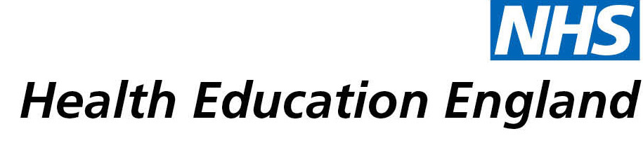

# Library and Knowledge Services case study

# *University Hospital Coventry and Warwickshire (UHCW) NHS Trust, Library and Knowledge Services Clinical Evidence Based Information Service (CEBIS) Team: Evidence search on CO2 monitoring as a proxy measure for viral load and impact of this on current and future practice*

*June 2021*

## Reason for enquiry

## *The UHCW NHS Trust Infection Prevention and Control (IPC) Department, in collaboration with Estates, wanted to understand whether there was evidence on CO2 monitoring as a proxy measure for viral load in the ambient atmosphere owing to the focus on COVID-19.*

## *The aim was to review whether there is a need for particular ventilation strategies, and/or for moving patients and others around if certain ppm values (the value measurement for CO2 load) meant the air was contaminated and needed quick resolution.*

## What the knowledge and library specialist did

*CEBIS, or the Clinical Evidence Based Information Service, at UHCW Trust includes a small team of information specialists. The CEBIS Specialist Helen Wesson searched for evidence via medical databases and Google Scholar advanced searching. As well as the literature on CO2 monitoring as a proxy measure for viral load, related topics on ventilation, heating and air conditioning (or HVAC) and risk reduction strategies for reopening buildings, were also included in the first March 2021 searches. HVAC and risk reduction strategy evidence in the main was coming from the schools and civil engineering sectors. The wider literature searching strategy allowed for a greater breadth of literature where the evidence on CO2 monitoring as a proxy measure alone, and also within the healthcare sector relating to COVID-19, was more limited.*

*Outside of these usual searches, the CEBIS Specialist also got in touch with a contact within the wider public sector in school buildings/capital build projects and asked them if there was any work or research in the pipeline relating to air quality and COVID-19 which might be applicable to the hospital setting. The contact will be in touch again with the CEBIS Specialist if any research on CO2 monitoring in schools comes through.*

*Since undertaking the initial searches in March 2021, a second search of the evidence has been conducted in June 2021 to provide an update to the evidence base and therefore to keep the IPC and Estates Teams abreast of the most up-to-date ways of addressing the question. Some of the evidence was published just days before, thus emphasising the nature of the pandemic and the related evidence base keeping up. The evidence emerging are experiments in classroom settings investigating ventilation or air purifier and similar approaches to controlling and/or reducing transmission. Other literature is looking at where poor air quality more widely may be aiding transmission, as well as a small number which specifically discuss monitoring air quality including carbon monoxide.*

# Impact of input from the library and knowledge service

## Immediate Impact

*In terms of the current impact of this, the COVID-19 pandemic represents one of the biggest global-level peacetime challenges in living memory. Kate Prevc, the search requestor says:*

*‘The search has made us consider the literature on CO2 monitoring and air quality afresh. It is important to understand what local-level responses are or should be, what our CO2 levels are in certain conditions and how this compares to what engineers tell us. This searching was carried out in order to support us in reviewing and potentially altering practice later on, both for our department and Estates. In an uncertain time when evidence is still emerging, and at a very rapid rate, it is always important to question and discuss what we think we know and in this case how CO2 level monitoring might help to keep patients and staff safe. For example, in the immediate term we are having different conversations with our engineers and architects and this search allowed us to consider alongside those conversations, the continually-emerging evidence base.’*

## Probable future Impact

*The potential future impact of knowing more about CO2 monitoring as a proxy measure for viral load, particularly in current times, is clear. By making the immediate air environment potentially safer for patients and staff in the short-term opens the door for potentially greater understanding around air quality and infection prevention and control for the future.*

## Submission by:

*[Kate Prevc (Kate left her Infection Prevention and Control Lead Nurse role at UHCW Trust in March 2021, and is now a Nurse Consultant at George Eliot NHS Trust)]*

## For further information on how you can get similar support contact your local NHS library and knowledge service.